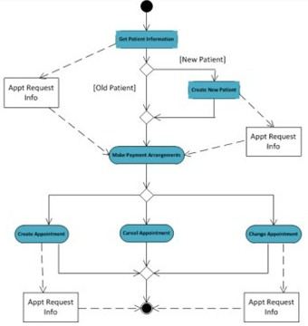

Work Flow

Conclusion

* The data management team involves the conversion of the old systems to new systems, the extraction of the data in the raw form according to the need, and generating custom reports and interfaces to deploy for the client.
* Being part of one such team ensures that the communication skills, managerial skills, and technical skills in data engineering and data science are refined and in turn helps achieve the desired uplifting results.

Project Details

**Jetwayz** is a full-stack flight management portal designed for airline operations and travelers.  
It includes the following modules :

* User Portal
* Flight Search Portal
* Booking Portal
* Admin Portal
* Payment Gateway Integration
* Notification System

Project Plan

* Begin with onboarding and technical training for Jetwayz architecture and tech stack.
* Undergo product walkthrough to understand core modules and workflows.
* Gather and analyze requirements from stakeholders (travelers, admins).
* Begin with the feasibility analysis, meetings and further procedures according to the tasks of the project.

Project Roles

* Conduct needful meetings or communicate accordingly.
* Get confirmation over the requirements of the client and keep a track of the same.
* Provide the needful analysis reports, prepare the questionnaire documents and have them answered by the client.
* Perform the extraction/conversion/report or interface generation and case solution in test environment for review
* Deploy the results in the live services after a successful review.



Prepared By: Deep Patel

Team ID: 404128

ERN: 210280107060